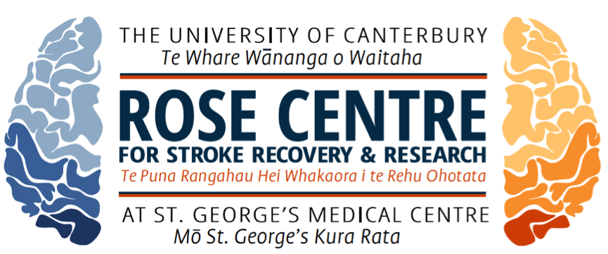

Maggie-Lee Huckabee PhD
Swallowing Rehabilitation Research Laboratory
Leinster Chambers, Level One; 249 Papanui Road, Merivale, Christchurch 8140
maggie-lee.huckabee@canterbury.ac.nz
Web: http://www.rosecentre.canterbury.ac.nz/

Title of event: The Changing Face of Swallowing Rehabilitation: From Peripheral to Central Modulation
Date of event:
Speaker name: Maggie-Lee Huckabee PhD
This event is suitable for:
- Practicing speech language pathologists, with a particular focus on, but not limited to, adult neurogenics. Although paediatric swallowing or dysphagia secondary to other aetiologies will not be directly addressed, the concepts should be transferrable to other populations who are candidates for rehabilitative intervention.
- Student speech therapists may find the course quite valuable if they have some basic knowledge of swallowing biomechanics and rehabilitation approaches.
- Other professionals with a special interest in dysphagia such as physiotherapists, doctors and specialist nurse practitioners.
Time Ordered Agenda
In very few areas of clinical practice is the rate of change moving as rapidly as in dysphagia diagnosis and management. The next years promise to bring about enormous changes in how we understanding swallowing neurophysiology and manage patients with neurogenic swallowing impairment. From greater precision in diagnostic specificity to far greater options in rehabilitative approaches, the skilled clinician will struggle to stay abreast and provide optimal care. It is an exciting time to work in this area. However, maintaining a solid foundation for this growth is critical.
Day 1 Going Deep: levels of assessment and understanding of swallowing pathophysiology

In our very early days of dysphagia practice, we focused heavily on identifying signs of dysphagia on clinical swallowing assessment. As instrumental assessments increased in availability, we shifted our focus to careful interpretation of swallowing biomechanics. But as our understanding of swallowing increases further, we now recognise that understanding biomechanics is insufficient for rehabilitation planning and we need to better develop our understanding and assessment of underlying physiology. We don’t need to know HOW things move or don’t move; we need to know WHY they do or don’t move. The first day of this two-day professional development event will consist of an integrative workshop for combining clinical and biomechanical analysis into more specific diagnoses of swallowing pathophysiology. The morning will provide an overview of clinical assessment practices with an emphasis on neurophysiology, followed by a brief review of biomechanics seen on videofluoroscopic swallowing study. The afternoon will consist of a series of case study analyses that integrate knowledge from a clinical assessment into radiographic interpretation, leading to an improved understanding of pathophysiology. Particular emphasis throughout the day will be paid to limitations in our current practices, which may heavily influence management decisions. Be prepared for active learning and application of neurophysiologic models of clinical and instrumental assessment in this WORKshop with the use of small groups to analyse clinical problems.

8:45 – 10:45 Swallowing Physiology Review:
What you learned once upon a time and forgot – Nerve -> Muscle -> Function
10:45 – 11:00 Morning Tea
11:00 – 12:30 The instrumental exam: Fundamental swallowing biomechanics
12:30 – 1:15 Lets Lunch!
1:15 – 2:45 Clinical case study: group work. Biomechanics vs physiology
2:45 – 3:00 Gotta have more tea
3:00 – 4:30 More clinical cases and The Test of Masticating and Swallowing Solids App – a new addition to our clinical assessment toolkit
4:30 Questions? Discussion. Good bye!

Day 2 The changing face of rehabilitation of swallowing:
The second day of the PD event will shift attention to a preview of the changing landscape of rehabilitative management. A significant conceptual shift is underway in approaches to rehabilitation of swallowing impairment. Emerging concepts related to the strength vs skill paradigm will be presented, followed by a discussion of potential rehabilitation approaches to accommodate this new thinking. sEMG biofeedback as a treatment adjunct will be introduced within the context of skill training paradigms. Potential options for skill training and supportive research will be discussed.
8:45 – 10:30 The problem with hammers: Limitations of current state of the ar
10:30-10:45 You got it…more tea!
10:45 – 12:15 Skill based rehabilitation: What is it?
12:15 – 1:00 Lunch and brain break
1:00 – 2:30 Expanding options for skill training
2:30 – 2:45 Last brain break
2:45 – 4:00 sEMG: new life for old technology
Strength vs Skill: clinical decision making.
4:00 Questions and Close

